Unit 10 Project/Test: Similarity Application

DIRECTIONS:

In this unit, you learned about similarity and triangles now you are going to put your skills into action. Ever wonder how tall something is? Using triangles and similarity you can figure it out. Following the following steps, put together a report on how you calculated the height of various objects.
- Measure how tall you are as well as the length of your shadow
- Create a triangle representing the measurements done of your height and shadow
- Find multiple tall objects (greater than 10 feet) whose height you don’t know and measure its shadow
  - These measurements must be done on the same day and at the same time you measure your own shadow
- Using the measurements, use your knowledge of similar triangles to calculate the height of the objects you measured
- Create triangles representing the measurements and calculations you did on your chosen objects
- Prepare a report showing your process throughout the project (pictures, etc…), measurements, calculations, triangle drawings, and include an explanation as to why the triangles you made for the various objects are similar

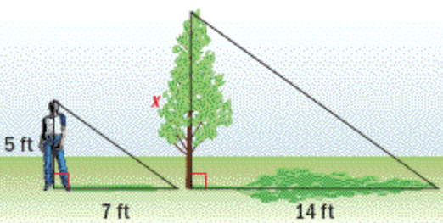

 | A | B | C | D | F
Evidence | Four or more pictures of both object you measured and yourself (in the same picture) | Pictures of three of the objects you measured | Pictures of two of the objects you measured | One picture of object you measured. | No pictures or evidence
Measurements | Measurements were done and recorded of yourself and four or more objects. | Three objects and yourself were measured and recorded. | Two objects and yourself were measured and recorded. | Measurements were done and recorded of yourself and one other object. | No measurements are recorded
Calculations | Calculations are organized, correct, and/or complete. | Calculations are organized and complete and contain minor errors. | Calculations contain major errors (incomplete/incorrect) and/or unorganized | Calculations are unorganized, incorrect, and/or incomplete. | No work or calculations are shown
Triangles | Each object has a neat and organized triangle representation showing the length of the shadow and calculated height. | Triangles are organized and neat but contain minor errors. | Representations are unorganized and contain major errors | Triangles are unorganized and hastily drawn. Contain incorrect or incomplete information | No triangle representations included in projects
Write Up | Write up is thorough and complete.  (1 page double spaced) | Explanations are complete but lacking in understanding of similarity.  (3/4 page double spaced) | Lacks depth and shows major misunderstanding of similarity.  (1/2 page double spaced) | Write up is incomplete and lacks explanations of similarity.  (1/4 page double spaced) | Write up is missing
Rubric
Write up Questions

- Explain the process you went through and how you can determine the height of the objects.
- Convince me using math and your understanding of similar triangles that the heights you found for your objects are correct.
- Think of a possible situation that you might be able to use this knowledge in the future and explain how it could be used.

