Secondary Math 2 Final Review Name ________________________
Date _________ Period ______

State the relationship, then solve for x.
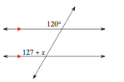
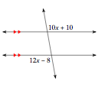
- L

Find the measure of the indicated arc or angle.
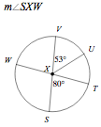 | 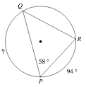

Find the missing length given that the triangles are similar.
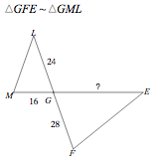

Determine the missing side or angle. Round to the nearest hundredth.
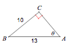 | 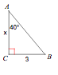

- A kite with a string 150ft long makes an angle of 45° with the ground. Draw a picture to represent the situation, then determine the height of the kite in the air.

Solve the quadratics below. SHOW ALL OF YOUR WORK. Leave as exact answers.
- $0=x^{2}+15x+56$ | - $3x^{2}-3x=36$
- $x^{2}-20x+58=0$ | - $3x^{2}-2x=120$
- $x^{2}-16=6x$ | - $9x^{2}-9x+7=0$

Graph the quadratic equations below. Then identify the key features.

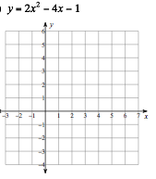 | Vertex:  x-int:  y-int:  Domain:  Range:  Increasing:  Decreasing:

Simplify the given expressions. Your answer should contain only positive exponents.

- $m^{-1}n^{-4}∙{{(-n}^{3})}^{-5}$ | - ${{(x}^{-4}y^{4})}^{0}∙x^{4}y^{0}$

Given $f\left(x\right)=5x^{2}-1$, find the average rate of change on the following intervals.

- $[0,3]$ | - $[-3,1]$
- Write the equation of a parabola with vertex at (3,-2) through the point (-1, 11) | - Write the equation of a parabola with x-intercepts at (-2,0) and (0,0) through the point (3,-12)

- Identify if the table below represents a linear, quadratic, or exponential function.
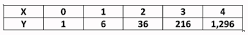

- Find the arc length and sector area of the specified section below. Give both exact and approximate answers.
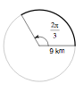

Find the missing angle.

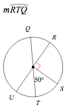  - K | 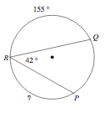

Solve the following systems.
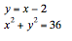
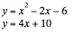

Use the two-way table to find the specified probabilities. Let I represent playing an instrument and S represent playing a sport.
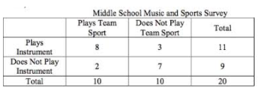

- $P(S∩I)$ | - $P(I^{C}∩S)$
- $P(S∪I)$ | - $P(S|I)$

