Name: __________________________________________________

Secondary Math 2

6.4 Quadratic Models on a Calculator

Remember for each problem to decide which key feature you are trying to find in order to answer the question.

1. 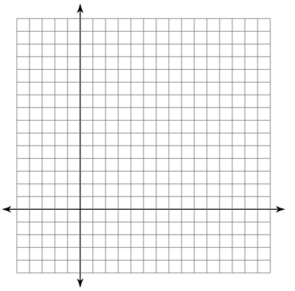A ball is thrown straight up, from 3 m above the ground, with a velocity of 14 m/s. This situation can be modeled by the function , where h is the height of the ball in meters and t is the time in seconds. Graph this function below.
   1. What is a reasonable domain and range for this situation?
   2. When will the ball hit the ground?
   3. What will be the max height of the ball?
2. Jason jumped off a cliff into the ocean in Acapulco while vacationing with his family. His height as a function of time could be modeled by the function , where t is the time in seconds and h is the height in feet.
   1. How long did it take for Jason to reach his maximum height?
   2. What was the highest point that Jason reached?
   3. Jason hit the water after how many seconds?
   4. What is a reasonable domain and range for this situation?
3. You and a friend are hiking in the mountains. You want to climb to a ledge that is 20 feet above you. The height of the grappling hook you throw is given by the function .
   1. Can you throw the grappling hook high enough to reach the ledge? Why or why not?
   2. What about the 25 foot ledge above that? Can you throw the grappling hook high enough to reach that ledge? Why or why not?
   3. In the context of this problem, what does the 5 represent in the equation above?
4. You are trying to dunk a basketball. You need to jump 2.5 feet in the air to dunk the ball. The height that your feet are above the ground is given by the function .
   1. What is a reasonable domain and range for this situation?
   2. Will you be able to dunk the basketball? Why or why not?
5. The profits of Mr. Unlucky’s company can be represented by the equation , where P is the amount of profit in hundreds of dollars and x is the number of years of operation. He realizes his company is on the downturn and wishes to sell before he ends up in debt.
   1. When will Unlucky’s business show the maximum profit?
   2. What is the maximum profit?
   3. When will it be too late to sell his business (when will he start losing money?)
6. A duck dives down in the water to eat a fish that is 5.5 feet from the surface. The ducks path can be modeled by the equation , where d is the ducks depth underwater and x is the horizontal distance during the dive. Graph this function below.
   1. 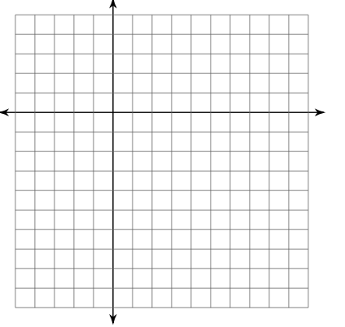What is a reasonable domain and range for this situation?
   2. Will the duck reach the fish? Why or why not?
   3. 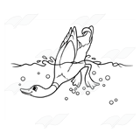Will the duck reach another fish that is 3.5 from the surface? Why or why not?