32) Write the situation that could be modeled by the following graph.

Write the equation for each piecewise function.

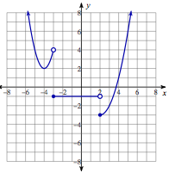  33) | 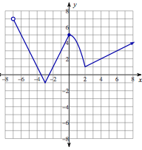  34)

State the initial value, growth/decay factor, and growth/decay rate of each.
35) $y={1.32}^{x}$ | 36) $y={12∙0.44}^{x}$
37) $y={63∙2.1}^{x}$ | 38) $y={1.08}^{3x}$
39) $y={18∙0.71}^{2x}$ | 40) $y={131∙0.87}^{4x}$

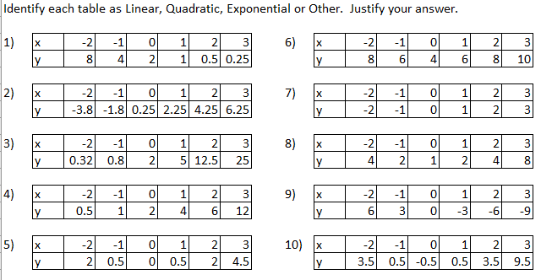
Extra Credit

6)

7)

8)

9)

10)

*You must have explanations to receive extra credit*

